NUMERICAL SIMULATIONS OF TRANSIENT FLOWS IN SHOCK TUBE AND
VALIDATIONS WITH EXPERIMENTAL MEASUREMENTS

M. Z. Yusoff, A. Al-Falahi, N. H. Shuaib and T. Yusaf
Centre for Advance Computational Engineering,
Department of Mechanical Engineering, College of Engineering,
Universiti Tenaga Nasional (UNITEN),
Putrajaya Campus, 43009, Selangor, Malaysia
E-mail: zamri@uniten.edu.my

KEYWORDS
Shockwave, Shocktube, Transient high speed flows.

ABSTRACT

This paper describes the numerical simulations of transient flows in shock tube which involves multiple reflections of shockwaves, contact surface and expansion waves and their interactions. The numerical formulations solve the fully compressible Reynolds Averaged Navier Stokes (RANS) equations set using finite volume method. The numerical results are validated against analytical solutions and experimental measurements in the high speed flow test facility available at the Universiti Tenaga Nasional (UNITEN), Malaysia. Experimental tests for different operating conditions have been performed. High precision pressure transducers were used to measure the pressure history at two different locations within the shock tube. Experimental results were compared with the numerical results and good agreements were obtained. The numerical simulations also revealed that the flow tend to be very unstable in the region close to the diaphragm after the reflected shock wave interacts with the contact surface.

INTRODUCTION

There are many different ways to generate a source of air at a sufficiently high temperature and pressure to act as the working fluid of a hypersonic wind tunnel. This includes hotshot tunnels, plasma jets, shock tubes, shock tunnels, free-piston tunnels and light gas guns (Pope and Goin, 1965). Various hypersonic wind tunnels have been constructed at different universities and research centers all over the world such as at University of Oxford (Buttsworth et al., 2002), University of Southampton in the United Kingdom (East, 1960), University of Queensland (Jacobs, 1994) and University of Southern Queensland in Australia (Buttsworth, 2002). However, these facilities are very costly and very expensive to run and maintain. A low cost facility, which could show the various effects of hypersonic ionization and dissociation, along with experimental testing of hypersonic heat transfer effects has been developed in Universiti Tenaga Nasional (UNITEN). The hypersonic test facility has been designed so that it can be easily used as a shock-tube, shock tunnel and free piston tunnel interchangeably (Yusaf et al., 2008). The objective of building such facility is to generate gas flows or gas conditions of sufficiently high temperature and pressure that are difficult to achieve in other test devices. The facility is to be used to test a new fiber-optic pressure sensor for high speed flows in gas and steam turbines, which is being developed and to study the heat transfer phenomena associated with high speed flows.

In order to compliment the experimental work, a specialized CFD solver has been developed for simulations of transient flows in the facility. The CFD solver solves the time accurate Reynolds Averaged Navier Stokes (RANS) equations set using second order accurate cell-vertex finite volume spatial discretization and fourth order accurate Runge-Kutta temporal integration and it is designed to simulate the flow process for similar driver/driven gases (e.g. Air-Air as working fluids). The solver is applied to inviscid standard Sod problem, inviscid flows in real shock tube and viscous flows in real shock tube. In the real shock tube, a bush is placed in the diaphragm section in order to facilitate the rupture process. Therefore, the effective area of the diaphragm (throat) opening at rupture will be some what smaller than the bush opening area. There will be also a dead flow region behind the bush. The exact location of the reattachment point will be highly dependent on the flow speed. In the present work, since the two parameters are not known, the effective throat area and the wedge angle were calibrated and the values which give the closest agreement between experimental data and simulation results will be used.

Experimental tests for different operating conditions have been performed. High precision pressure transducers were used to measure the pressure history at two different locations within the shock tube. The analytical and experimental results were compared with the numerical results and good agreements were obtained.

NUMERICAL FORMULATION OF THE SOLVER

The two-dimensional continuity, x- and y-momentum and energy equations describing the turbulent flow of a compressible fluid expressed in strong conservation form in the x-, y-cartesian co-ordinate system may be written as

$\frac{∂\underline{w}}{∂t}+\frac{∂\underline{F}}{∂x}+\frac{∂\underline{G}}{∂y}=\underline{J}$ (1)

where w represents the conserved variables. F and G are the
overall fluxes in x-, y-directions respectively:

$\underline{F}=\underline{F_{C}}−\underline{F_{V}}−\underline{F_{T}},$ (2)
$\underline{G}=\underline{G_{C}}−\underline{G_{V}}−\underline{G_{T}},$ (3)
and
$\underline{w}=\begin{aligned}\left(ρ | \right)\left(ρ u | \right)\left(ρ v | \right) \\ \end{aligned}$, $\underline{F_{C}}=\begin{aligned}\left(ρu | \right)\left({ρu}^{2}+P | \right)\left(ρ\text{uv} | \right) \\ \end{aligned}$,$\underline{G_{C}}=\begin{aligned}\left(ρv | \right)\left(ρ\text{uv} | \right)\left({ρv}^{2}+P | \right) \\ \end{aligned}$

$\underline{F_{V}}=\begin{aligned}\left( 0 | \right)\left(\frac{4}{3}μ\frac{∂u}{∂x}−\frac{2}{3}μ\frac{∂v}{∂y} | \right)\left( μ\frac{∂u}{∂y}+μ\frac{∂v}{∂x} | \right) \\ \end{aligned}$

$\underline{F_{T}}=\begin{aligned}\left( 0 | \right)\left(−ρ{\overline{u'}}^{2} | \right)\left(−ρ\overline{u'v'} | \right) \\ \end{aligned}$

$\underline{G_{V}}=\begin{aligned}\left( 0 | \right)\left( μ\frac{∂u}{∂y}+μ\frac{∂v}{∂x} | \right)\left(\frac{4}{3}μ\frac{∂v}{∂y}−\frac{2}{3}μ\frac{∂u}{∂x} | \right) \\ \end{aligned}$

$\underline{G_{T}}=\begin{aligned}\left( 0 | \right)\left(−ρ\overline{u'v'} | \right)\left(−ρ{\overline{v'}}^{2} | \right) \\ \end{aligned}$

The turbulence terms are calculated by using mixing length turbulence model. The numerical scheme was based on an earlier work by the author as described in Bakhtar et al. (2007) and Bakhtar et al. (2008). The earlier program was developed for two-dimensional transient flow of two-phase condensing steam in low pressure turbine. In the current work modifications were made so that the program can be applied for high speed viscous flow in shock tube.

The first part of the spatial discretization consists of setting up a mesh or grid by which the flow domain is replaced by a finite number of points where the numerical values of the variables will be determined. In the present work, the physical domain is divided into a set of grids consisting of pitch-wise lines and quasi-streamlines. A cell-vertex formulation is used in which the flow variables are stored at cell vertices. It has been shown by Martinelli (1987), Dick (1990) and Swanson and Radiespiel (1991) that cell-vertex formulation offers some advantages over the cell-centred one. Since the variables are piece-wise linear over the cell face, the formulation is second-order accurate in space irrespective of the irregularity of the grid. On the other hand, the cell-centred formulation will only be first-order accurate on an irregular grid since the representation of the solution is done in piece-wise constant way. For a uniform mesh, there would be no difference between the cell-centred and cell-vertex schemes, however, cell-vertex scheme does not require extrapolation to the solid boundary to obtain the wall static pressure which is necessary in solving the momentum equations for cells adjacent to the solid boundary .

Central-difference generates odd-even decoupling near a discontinuity. The scheme can be stabilised by introducing a small amount of artificial viscosity. The artificial viscosity used in the present work, is that proposed by Jameson et al. (1981) modified to suit the cell-vertex formulation. This is a blend of second and fourth-order terms with a pressure switch to detect changes in pressure gradient. The time integration is done by means of a four-stage Runge-Kutta time stepping scheme, as proposed by Jameson et al. (1981).

EXPERIMENTAL FACILITY

Figure 1 shows the schematic diagram and a photograph of the high speed test facility. The facility consists of the following components as listed in Figure 1(a) :

- Driver section - A high-pressure compressed air section (driver), which contains high pressure driver gas.
- Pressure gauge - The gauge is used to measure the pressure inside the driver section.
- Discharge valve – A valve use to discharge the driver section after each run.
- Primary diaphragm – A thin sheet of metal use to isolate the low-pressure test gas from the high-pressure driver gas until the compression process is initiated.
- Piston compression section - A piston is placed in the barrel (driven tube) adjacent to the primary diaphragm so that when the diaphragm ruptures, the piston is propelled through the driven tube, compressing the gas ahead of it.
- Discharge valve - A valve use to discharge the driven section after each run.
- Vacuum gauge - The gauge is use to set the pressure inside the barrel section to the required vacuum pressure.
- Barrel section - A shock tube section to be filled with the required test gas.
- Barrel extension - The last half meter of the barrel on which the pressure transducers and thermocouples are attached.
- Secondary diaphragm - A light plastic diaphragm which separates the low pressure test gas inside the barrel from the test section and dump tank which are initially at a vacuum prior to the run.
- Test section – This section consists of a nozzle and test section. The nozzle allows the high temperature test gas to expand to the correct high enthalpy conditions needed to simulate hypersonic flow. A range of Mach numbers can be obtained by changing the diameter of the throat insert. Model to be tested can be put inside the test section. The test section has a clear window made of high strength glass for flow visualization.
- Vacuum vessel – The vessel is to be evacuated to about 0.1 mm Hg pressure prior to a test.
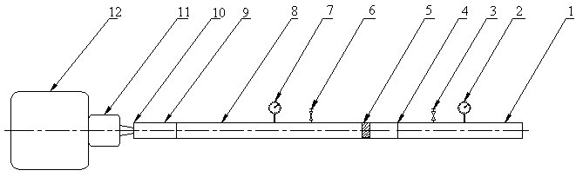

Figure 1(a) : Schematic Diagram of the Hypersonic
Test Facility at UNITEN

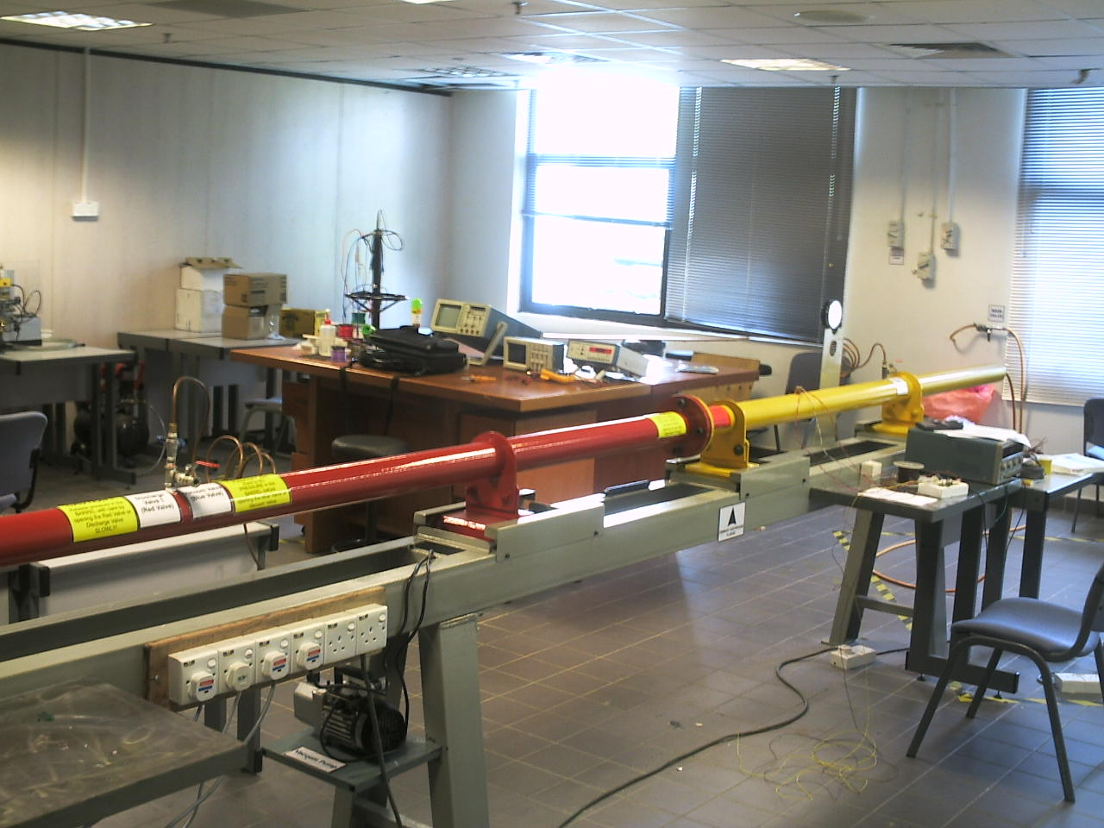

Figure 1(b) : Photograph of the hypersonic test
facility at UNITEN

The facility consists of two major sections, the driver section and the driven section. These two sections are filled with gasses at 2 different pressures and are initially separated by a thin diaphragm. The diaphragm is designed to withstand a certain pressure ratio. When this ratio is exceeded, the high-pressure gas ruptures the diaphragm and expands into the low-pressure gas.

VALIDATION OF THE CFD CODE

In order to ensure the validity of the CFD code, in terms of the ability to capture shocks and contact discontinuity and to produce the correct pressure, density and speed profiles, two verification approaches have been used. The first one is the validation of the code against a standard analytical solution of the shock tube problem. The second is to compare the code solution with selected experimental measurements for a certain case of diaphragm pressure ratio.

Comparison with Exact Solution for Inviscid Flow in Shock Tube (Sod Problem)

The Sod problem (Sod, 1978) is an essentially one-
dimensional flow discontinuity problem which provides a good test of a compressible code's ability to capture shocks and contact discontinuities with a small number of zones and to produce the correct density profile in a rarefaction. The problem spatial domain is 0 ≤ x ≤ 1 as shown in Figure 2.

The initial solution of the problem consists of two uniform states, termed as left and right states, separated by a
discontinuity at the origin, x_{o} = 0.5. The fluid is initially at rest on either side of the interface, and the density and pressure jumps are chosen so that all three types of flow discontinuity (shock, contact, and rarefaction) develop. To the ``left'' and ``right'' of the interface we have, ρ_{L} = 1, ρ_{R} = 0.125, P_{L} = 1, P_{R} = 0.1, u_{L} = 0, and u_{R} = 0. The ratio of specific heats γ is chosen to be 1.4 on both sides of the interface.
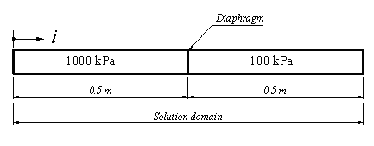
Figure 2: Solution domain for Sod’s Problem

A uniform grid spacing with the number N = 356 is used. The boundary conditions of the problem are held fixed as a short time span of the unsteady flow is considered. The wave pattern of this problem consists of a rightward moving shock wave, a leftward moving rarefaction wave and a contact discontinuity separating the shock and rarefaction waves and moving rightward.

Figure 3 shows comparisons between the present results for the pressure, density and Mach number at a time t = 0.2 ms and the exact solutions. It can be observed that the present solver is capable of capturing the different types of discontinuities accurately.

Figure 3: Results for the Sod’s shock tube problem at t = 0.2 ms

Comparison with Experimental Data for Viscous Flow in Shock Tube

In order to validate the numerical formulation for the viscous terms, the solver was applied to transient shock wave motion in real shock tube. The results will be compared with the experimental measurements done on the new short duration high speed flow test facility. In order to facilitate the process of diaphragm rupture and avoid any shear a small bush is designed with rounded edge and this bush is to be inserted in the driven section adjacent to the diaphragm, details of this bush is shown in Figure 4.
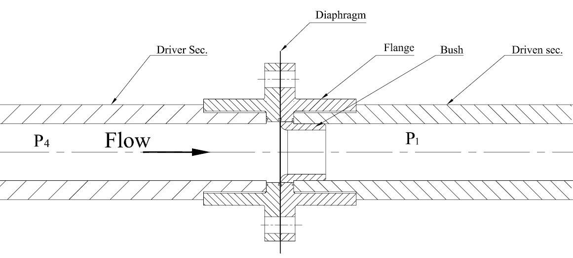
Figure 4: Diaphragm section of the shock tunnel

In order to represent the bush, in the solver, an artificial wedge was included. The CFD simulations are compared with experimental measurements at the test facility for air-air gas combination at diaphragm pressure ratio of 8.8. In the experiment, the transient pressure history at x = 6183 mm from the right hand side end wall was measured by using a highly sensitive piezoelectric pressure transducer. In the actual experiment, the effective area of the diaphragm (throat) opening at rupture is some what smaller than the bush opening area. There will be also a dead flow region (re-circulating flow) behind the bush as shown in Figure 5.

Figure 5: Re-circulating flow behind the bush

The exact location of the reattachment point is highly dependent on the flow speed. In the present work, since the two parameters are not known, the effective throat area and the wedge angle are calibrated and the values which give the closest agreement between experimental data and simulation results are used.

Figure 6 shows comparisons of predicted and measured pressure history with throat opening of 24 mm, 18 mm and 14 mm. All cases are able to predict the overall shock wave motion. The first pressure jump is the shock wave. This is followed by the second pressure jump due to the passing of the reflected shock wave. The pressure history after that also mimics the experimental measurement very well and shows the arrival of the contact discontinuity and subsequent interaction with shock wave. Comparing the three throat diameters, it can be seen that the shock wave strength reduces and get closer to the measured values as the diameter is reduced. The case with throat diameter of 14 mm gave the closet agreement with the experiment and therefore will be used in the subsequent investigation.

Figure 6: Experimental and CFD results of pressure history at different rupture area

Having fixed the throat diameter, the next parameter is the effect of wedge angle. Three wedge angles have been used; 3.5º, 5º and 6.5º and the results obtained are shown in Figure 7. It can be seen that as he wedge angle is increased the peak pressure reduced. The wedge angle that gave the closest agreement is 5º wedge.

Figure 7: Experimental and CFD results of pressure history at different wedge angle

The x-t diagram is one of the important tools which give a good estimation for the maximum useful test time that can be obtained after removal of the diaphragm. Figure 8 shows the predicted x-t diagram for density profile along the whole length of the test facility obtained for diaphragm pressure ratio of (P₄/P₁) =10. It can been seen that the shock wave is followed by the contact surface. Then the reflected shock wave interacts with the contact surface and then the wave further reflects. It is interesting to note that after interaction with the reflected shock wave, the contact surface remains at about the same position, indicating achievement of the tailored condition. The presence of the bush is also seen to have prevented the rarefaction wave and the shock wave from passing to the other section. The rarefaction wave and the shock wave are reflected when they reach the bush.

Figure 8: x-t diagram for the density history

It can be concluded, based on the agreement with the analytical results, that the numerical formulation of the solver is valid.

RESULTS AND DISCUSSION

Inviscid Transient Flow in Shock Tube

CFD solution for inviscid simulation for a diaphragm pressure ratio P₄/P₁ of 10 has been chosen for detail investigation. The pressure, temperature, density and Mach number of the flow were stored in two stations at the end of the barrel with an axial separation of 342 mm as shown in Figure 9.
Figure 9: The two stations at the end of the facility

The pressure history for the above mentioned shot is depicted in Figure 10 from which one can follow the physics of the flow inside the shock tube. The first jump represents the shock wave, for which the pressure inside the barrel increases from 100 kPa to around 220 kPa. As the shock wave proceeds to the end of the tube it will reflects and moves in the opposite direction increasing the pressure to about 450 kPa. The shock wave will then interact with the contact surface which is following the shock wave and due to this interaction between the shock wave and the contact surface the pressure will be increased until it reaches its peak pressure value of 530 kPa.

The shock wave speed can be determined from the CFD data obtained from this simulation. As the distance between the two stations is known (0.342 m) and the time of shock travels from station 1 to station 2 can be obtained from the pressure history graph, as shown in Figure 10, the shock wave speed is determined for this shot is 518 m/s. Comparing to the theoretical value for this pressure ratio (558 m/s), the percentage difference is around 7% is reasonable. The difference is probably due to the two-dimensional effect which is not modeled by the theoretical solution. From experimental measurements the shock speed for the same pressure ratio is 450 m/s, which indicate percentage difference of about 13% from CFD results.

Figure 10: Pressure history for inviscid flow (P₄/P₁=10)

Using the same procedure, the reflected shock wave speed can be determined. As the wave reflects from the tube end and moves in the opposite direction (left direction), due to impact with the end wall the wave will lose some of its kinetic energy and consequently its speed decreases to about 342 m/s.

The same trend can be noted when the temperature history is investigated as shown in Figure 11. The first jump in the temperature profile represents the shock wave and the second jump is due to the reflected shock wave. The temperature is increased from the initial value 300 K to about 380 K due to shock wave effect and when the shock reflects from the tube end, the temperature rises to 475 K and after interaction between reflected shock wave and the contact surface; the flow temperature becomes about 490 K.
Figure 11: Temperature history inside the shock tube (inviscid flow)

Two-Dimensional Effects

The presence of the bush has caused the flow in the facility to be two-dimensional and this requires two-dimensional CFD simulations. The contour plots of the velocity in x-direction along the facility at selected times are shown in Figure 12.
a: Velocity contour before shock reflection (t = 0.0007 sec)
b: Velocity contour before shock reflection (t = 0.001 sec)
c: Velocity contour before shock reflection (t = 0.0015 sec)
d: Velocity contour before shock reflection (t = 0.003 sec)

Figure 12: Velocity contour plots in x-direction
at selected times

As the shock wave reflects from the tube end it will move to the left and interact with the contact surface and the flow no longer symmetry as shown in Figure 13.
Figure 13: Velocity contour after shock reflection and interaction with contact surface (t = 0.0125 sec)

The velocity contours at 0.025s after diapraghm rupture are shown in Figure 14. It can be observed that the flow is highly two-dimensional especially in the region close to the bush in the driven section. It is interesting to note that after t = 0.0125 sec, the velocity in area close to the bush becomes asymmetric. The asymmetry becomes more and more obvious as time progress and creating recirculating region. However the extend of the recirculating region is of about 10 diameter of the bush.
Figure 14: Velocity contour after shock reflection and interaction with contact surface (t = 0.02 sec)

To investigate further, the velocity profiles at x = 279 mm from the diaphragm are plotted in Figures 15 and 16 at different times. At time t = 0.001 sec the profile is perfectly symmetrical. However, the velocity profile contains inflexion part, which is according to Drazin and Reid (1993) is unstable and susceptible to disturbances. The asymmetry becomes more apparent as the process continues. The upper half of the tube has mainly positive velocity whereas the bottom half has negative velocity.

Figure 15: Velocity profile after diaphragm rupture at x = 279 mm from diaphragm

The formation of the recirculating region in this inviscid simulation is surprising especially considering that the tube is symmetrical. However, it has been reported in Xu and Xu (1992) that high speed flow tend to become unstable when shock wave interact with contact discontinuity.

a)after shock reflection b) after interaction with
contact surface
Figure 16: Flow after shock reflection

Figure 17 shows the velocity-time plot at selected points in radial direction along the facility which clearly shows oscillating flows.
Figure 17: Velocity evolution at selected points
in radial direction

Viscous Transient Flow in Shock Tube

In order to investigate the effect of viscosity on the transient flow in shock tube and how it affects the performance of the facility, a viscous simulation has been accomplished for the same boundary conditions of the inviscid simulation presented in the previous section. The pressure history for the above mentioned shot is depicted in Figure 18. The Figure shows similar trend as for the inviscid flow. The first jump represents the pressure rise due to shock wave, for which the pressure inside the barrel increases from 100 kPa to around 220 kPa. The shock wave then reflects as it hits the end of the tube and moves in the opposite direction subsequently the pressure increases to about 450 kPa.

The shock wave will then interact with the contact surface which is following the shock wave and due to this interaction between the shock wave and the contact surface the pressure will be increased until it reaches its peak pressure value which is in this case equal to around 530 kPa.

Figure 18: Pressure history for viscous flow (P₄/P₁=10)

The shock wave speed is determined for this shot is 456 m/s, comparing to inviscid value for the same pressure ratio (518 m/s) the effect of viscosity becomes obvious. It can be seen that viscosity decreases the shock wave speed to about 11% due to the boundary layer effects. From experimental measurements the shock speed for the same pressure ratio is 450 m/s, which indicate percentage difference of about 1.3% from CFD results. After it hits the tube end, shock wave will be reflected and it will move to the left with a slower velocity which can be determined using the same procedure. The wave speed decreases to about 311 m/s. Comparing with respect to the reflected shock wave speed for inviscid flow which is 342 m/s, it is apparent that viscosity resists the fluid motion causing slower speed of the shock wave by 9.1%.

Analyzing the temperature history for this simulation, it can be seen that the trend is quite similar to pressure history. The temperature results for this run have been displayed in Figure 19. The first jump represents the shock wave and the second jump is due to the reflected shock wave. The temperature is increased from the initial value 300 K to about 500 K.

Figure 19: Temperature history inside the shock tube (viscous flow)

CONCLUSIONS

The paper described the use of the 2D-CFD solver designed for simulation of flow in shock tube. The program has been applied to a standard case of inviscid flow in shock tube and transient flow in real shock tube. The agreement with the analyzed solution is very good which proved the validity of the basic numerical scheme developed.

Experimental and CFD pressure data achieved from the above runs showed the effects of shock wave propagation through the barrel, as the shock wave travels from the burst diaphragm, it increases pressure and temperature of the driven gas. The shock reflects off the closed end of the barrel and passes back through the driven gas, further processing the gas causing further increase of the pressure and temperature. The shock strength of the experimental and that of CFD results are very much comparable.

REFERENCES
Bakhtar, F., Zamri, M.Y. and Rodriguez-Lelis, J.M., 2007, “A Comparative Study of Treatment of Two-Dimensional Two-Phase Flows of Steam by a Runge-Kutta and by Denton’s Methods”, Proceedings of the IMechE, Part C Journal of Mechanical Engineering Science, Volume 221, Number 6, pp. 689-706(18)
Bakhtar, F, Otto, S.R., Zamri, M.Y, Sarkier, J.M., 2008, “Instability in two-phase flows of steam”, Proceedings of the Royal Society A: Mathematical, Physical and Engineering Sciences, Volume 464, Number 2091, pp 537–553, Royal Society Publishing, UK
Buttsworth, D.R, 2002, ‘Heat transfer during transient compression: measurements and simulation’, Shock Waves, 12 : 87-91.
Buttsworth, D.R, Jacobs, P.A, and Jones, T.V, 2002, ‘Simulation of Oxford University Gun Tunnel performance using a quasi-0ne-dimensional model’, Shock Waves, 11: 377–383
Dick, E., 1990, ‘Introduction to Finite Volume Techniques’, V.K.I Lecture Series
Drazin, P.G. and Reid, W.H., 1993, ‘Hydrodynamic Stability’, Cambridge Monographs on Mechanics and Applied Mathematics, Cambridge University Press.
East, R.A., 1960, ‘The performance and operation of the University of Southampton hypersonic gun tunnel’, Univ. of Southampton Aero. and Astro. Rep. no. 135.
Jacobs, P.A., 1994, ‘Quasi-One-Dimensional Modeling of a Free-Piston Shock Tunnel’, AIAA Journal, Vol.32, No. 1, January.
Jameson, A., Schmidt, W. and Turkel, E., 1981, 'Numerical Solutions of the Euler Equations by Finite Volume Methods using Runge-Kutta Time Stepping Schemes' AIAA Paper No. 81-1259
Martinelli, L., 1987, 'Calculations of Viscous Flows with a Multigrid Method', Ph.D Thesis, MAE Department, Princeton University
Pope, A. and Goin, K.L., 1965, ‘High-Speed Wind Tunnel Testing’, John Wiley, New York.
Sod, G.A. “A survey of several finite difference methods for systems of nonlinear hyperbolic conservation laws”, J. Comput. Phys. 43 (1-31), 1978.
Swanson, R.C. and Radespiel, R., 1991, ‘Cell Centred and Cell Vertex Multigrid Schemes for the Navier Stokes Equations.’AIAA Journal May 1991
Yusaf, T, Al-Falahi, A., Yusoff, M.Z., 2008, “Development of a Short Duration Hypersonic Test Facility and Universiti Tenaga Nasional”, Journal Institute of Engineers, Malaysia, Vol. 69, No. 1, pg. 32-38
Xu Fu and Xu Cuiwei, 1992, “Instability theory of shock wave in a shock tube”, Journal of Acta Mechanica Sinica, Volume 8, Number 2/May, Springer Berlin /Heidelberg.

